Journal of Technology and Information Education (JTIE)
Research Article | Open Access
AI-Driven Hull Defect Evolution Prediction: A Hybrid Physics-Informed Deep Learning Framework for Maritime Structural Health Monitoring
Naval Structural AI Lab, Hydrodynamic Mechanics Group, Autonomous Marine Systems
Department of Naval Architecture & Marine Engineering, National Maritime University, Busan, South Korea
Department of Mechanical Engineering, Maritime Technology Institute, Southampton, United Kingdom
Department of Computer Science & Robotics, Ocean Informatics Research Center, Trondheim, Norway
*Corresponding Author Email: nsail@maritime.ac.kr | ORCID: 0000-0002-1823-9481
Abstract: Commercial and naval marine structures are continuously subjected to severe cyclic hydrodynamic slamming, stochastic wave-induced bending moments, and aggressive electrochemical marine environments. These phenomena drive progressive structural degradation, predominantly localized pitting corrosion, plate thinning, coating delamination, and high-cycle fatigue crack propagation. Traditional structural health monitoring (SHM) paradigms rely almost exclusively on calendar-based dry-dock visual inspections and empirical corrosion wastage curves. However, these methods fail to capture non-linear, environmental-dependent defect kinetics across multi-decade operating envelopes. This paper introduces an end-to-end Physics-Informed Deep Learning (PINN) architecture coupled with Spatio-Temporal Graph Neural Networks (ST-GNN) to accurately forecast multi-mechanism hull defect evolution. By embedding governing electrochemical kinetics and Linear Elastic Fracture Mechanics (LEFM) directly into the neural surrogate's loss objective, the network guarantees physical plausibility while simultaneously capturing complex spatial stress redistributions across stiffened panels. The model ingests heterogeneous non-destructive testing (NDT) data, including ultrasonic thickness gauging, pulsed eddy currents, and autonomous underwater vehicle (AUV) photogrammetric reconstructions. Validated against a comprehensive 15-year longitudinal dataset spanning 142 structural compartments of a Post-Panamax bulk carrier, our hybrid model achieves a Mean Absolute Error (MAE) of 0.089 mm in corrosion wastage prediction and a Root Mean Square Error (RMSE) of 0.94 mm in crack propagation length. This represents a 71.4% accuracy improvement and a complete elimination of non-physical mass-gain anomalies compared to purely data-driven recurrent baselines, providing a foundational tool for autonomous condition-based maintenance.
Keywords: Physics-Informed Neural Networks (PINN), Ship Hull Inspection, Spatio-Temporal Graph Neural Networks (ST-GNN), Linear Elastic Fracture Mechanics, Corrosion Wastage Prediction, Structural Health Monitoring (SHM), Autonomous Underwater Vehicles (AUV).
1. Introduction
The structural integrity of commercial ships, offshore floating production storage and offloading (FPSO) units, and naval surface combatants represents a paramount operational, economic, and environmental safety challenge. Throughout a vessel's typical 25 to 30-year operational lifecycle, the hull girder is exposed to severe cyclic hydrodynamic loads, slam-induced whipping stresses, and a highly corrosive, chloride-rich marine atmospheric-submerged boundary layer (Garbatov & Guedes Soares, 2013).
Corrosion and fatigue cracking represent the two most pervasive and hazardous degradation mechanisms in maritime steel structures. Pitting corrosion not only diminishes the nominal cross-sectional load-bearing area of bottom plating and longitudinal stiffeners but also acts as geometric stress raisers that initiate micro-cracks under fluctuating sea-state stresses (Melchers, 1999; Verma & Das, 2008). As fatigue cracks propagate across welded joints and web frames, the catastrophic risk of hull girder fracture or progressive structural collapse escalates significantly (Downes et al., 2017).
Historically, maritime classification societies—such as Det Norske Veritas (DNV), the American Bureau of Shipping (ABS), and Lloyd's Register (LR)—have enforced prescriptive, calendar-based Special Survey schedules, typically every 5 years (DNV, 2020). During these surveys, dry-docking is mandatory, requiring human inspectors to conduct manual visual assessments and point-by-point Ultrasonic Thickness (UT) gauging. While established, this approach possesses critical limitations: (1) it offers zero temporal visibility between five-year intervals, (2) manual inspection in confined ballast and fuel tanks poses severe human safety hazards, and (3) standard empirical wastage allowance equations rely on highly conservative linear assumptions that overlook dynamic operational routes, water temperature variations, and cyclic cargo loading profiles (Zhang et al., 2021).
Recent advancements in autonomous robotics, specifically Autonomous Underwater Vehicles (AUVs) and magnetic hull-crawling robots equipped with Phased Array Ultrasonic Transducers (PAUT) and high-definition stereoscopic cameras, have made opportunistic in-water inspections feasible (Milani & Kianoush, 2021; Wang et al., 2020). However, the resulting data streams are characterized by spatial sparsity, non-uniform temporal intervals, high acoustic noise, and sensor drift. Purely data-driven machine learning architectures, such as standard Long Short-Term Memory (LSTM) networks or Convolutional Neural Networks (CNNs), frequently generate physically unviable predictions when operating in sparse-data regimes—such as forecasting spontaneous steel thickness regeneration or negative crack growth rates (Liu et al., 2022).
To overcome these fundamental deficiencies, this paper proposes a unified Physics-Informed Deep Learning framework for hull defect evolution forecasting. Let a stiffened hull structure be represented as a spatial domain Ω ⊂ ℝ³ bounded by surface ∂Ω. The instantaneous structural state at coordinate vector x ∈ Ω and voyage time t ≥ 0 is characterized by the multi-physics state vector:
S(x, t) = [ d(x, t), a(x, t), K_I(x, t), σ_eq(x, t) ]ᵀ (1)
where d(x, t) represents local plate thickness diminution (corrosion wastage depth in mm), a(x, t) is the equivalent fatigue crack half-length (mm), K_I(x, t) is the Mode-I stress intensity factor (MPa·√m), and σ_eq(x, t) represents the local Von Mises effective stress field (MPa).
Our objective is to learn a continuous neural spatio-temporal operator F_θ parameterized by weights θ that maps historical multi-modal inspection sequences and operational environmental covariates E(t) to future degradation trajectories:
Ŝ(x, t + Δt) = F_θ ( {S(x, τ)}_{τ=0}^{t}, E(t) ) (2)
where E(t) comprises significant wave height (H_s), modal wave period (T_p), seawater salinity, localized temperature, microbial activity index, and vessel draft/speed profiles.
2. Literature Review
Maritime degradation forecasting has historically relied on empirical models parameterized from historical fleet surveys. Paik et al. (2003) developed non-linear time-dependent corrosion models for bulk carriers, capturing coating breakdown and steady-state wear. Garbatov and Guedes Soares (2013) expanded these formulations using non-linear differential approximations. While effective for macroscopic fleet-level asset depreciation, empirical formulations lack adaptability to vessel-specific voyage histories, localized stress hot-spots, and dynamic oceanographic variations.
With the advent of deep learning in structural health monitoring, recurrent neural networks (RNNs) and Long Short-Term Memory (LSTM) networks have been widely applied to structural fatigue life prognosis (Liu et al., 2022). However, purely data-driven models are prone to overfitting and physical violations when applied to sparse inspection schedules. To address physical consistency, Raissi et al. (2019) and Karniadakis et al. (2021) pioneered Physics-Informed Neural Networks (PINNs), which directly embed partial differential equations (PDEs) into the loss function via automatic differentiation.
Furthermore, ship hulls represent non-Euclidean topological assemblies of stiffened plates and bulkheads. Traditional convolutional neural networks struggle with irregularly spaced sensor grids. Graph Neural Networks (GNNs) and Chebyshev spectral graph convolutions (Kipf & Welling, 2017; Chen et al., 2022) provide a mathematically sound formulation for modeling physical load transfer across welded structural details. This research synthesizes these advancements into a unified PINN-GNN paradigm tailored specifically for maritime asset life prediction.
3. Theoretical Framework & Methodology
3.1 Electrochemical Corrosion Kinetics
Marine corrosion wastage is inherently non-linear and exhibits distinct phenomenological phases: (i) an initial coating degradation and inhibition period, (ii) an active non-linear degradation phase driven by oxygen diffusion and localized pitting, and (iii) a stabilized steady-state phase where dense rust scales create an electrochemical diffusion barrier. We adopt a generalized non-linear time-dependent formulation governing expected corrosion loss d(t):
d(t) = d_∞ · [ 1 - exp( -((t - t_0) / τ_c)^β ) ] · ψ(T_w, Sal) (3)
where d_∞ denotes ultimate asymptotic corrosion depth, t_0 is coating life allowance (years), τ_c is characteristic transition scale parameter, and β is structural shape parameter governing curvature. The environmental scaling operator ψ(T_w, Sal) accounts for ambient seawater temperature T_w (via Arrhenius activation energy kinetics) and salinity Sal:
ψ(T_w, Sal) = exp( -E_a / (R · T_w) ) · (1 + γ_s · Sal) (4)
where E_a is activation energy for steel dissolution in chloride solutions, R is universal gas constant, and γ_s is empirical salinity sensitivity coefficient.
3.2 Linear Elastic Fracture Mechanics and Fatigue Crack Growth
Fatigue damage accumulation in ship structural details (such as welded hopper knuckle joints, longitudinal stiffener intersections, and hatch corner cutouts) is governed by fluctuating stress intensity ranges under high-cycle hydrodynamic wave action. The local Mode-I stress intensity range ΔK_I is expressed as:
ΔK_I = Y(a, W_p) · Δσ_wave · √(π · a) (5)
where Y(a, W_p) is the dimensionless boundary correction geometry factor as a function of crack size a and panel width W_p, and Δσ_wave represents wave-induced nominal stress range. Under variable amplitude loading spectra, crack propagation per load cycle N is modeled via the modified Paris-Erdogan law:
da / dN = C · (ΔK_I)^m · [ (1 - (ΔK_th / ΔK_I)^n1) / (1 - (K_max / K_IC)^n2) ] (6)
where C and m are Paris material parameters determined through standard ASTM E647 compact tension testing of marine-grade AH36 / DH36 structural steels, ΔK_th is fatigue threshold stress intensity factor range, K_IC is plane-strain fracture toughness, and n1, n2 are empirical asymptotic shaping exponents.
3.3 Multi-Source Sensor Ingestion and Preprocessing
Modern maritime asset management involves heterogeneous data collection paradigms across the vessel lifecycle. Our framework incorporates an automated ingestion, noise-filtering, and spatial-registration pipeline that reconciles asynchronous sensor measurements into a unified topological grid, detailed in Table 1.
Table 1. Multisensor Ingestion Specifications and Measurement Capabilities
Sensor Modality | Hardware Type | Sampling Rate / Res | Target Physical Metric
Visual / Optical | Stereo AUV Cameras | 0.08 mm/pixel | Coating delamination, rust grade
Ultrasonic (UT) | Dry-Coupled PAUT | 1.0 - 5.0 MHz | Residual plate thickness h(x, t)
Electromagnetic | Pulsed Eddy Current | 5 mm grid array | Sub-surface micro-cracking & pits
Acoustic Emission | Piezoelectric Arrays | 20 kHz - 1.0 MHz | Active crack tip plastic deformation
Vessel Telemetry | IMU & Hull Fiber FBG | 50 Hz Continuous | Global Vertical Bending Moment (VBM)

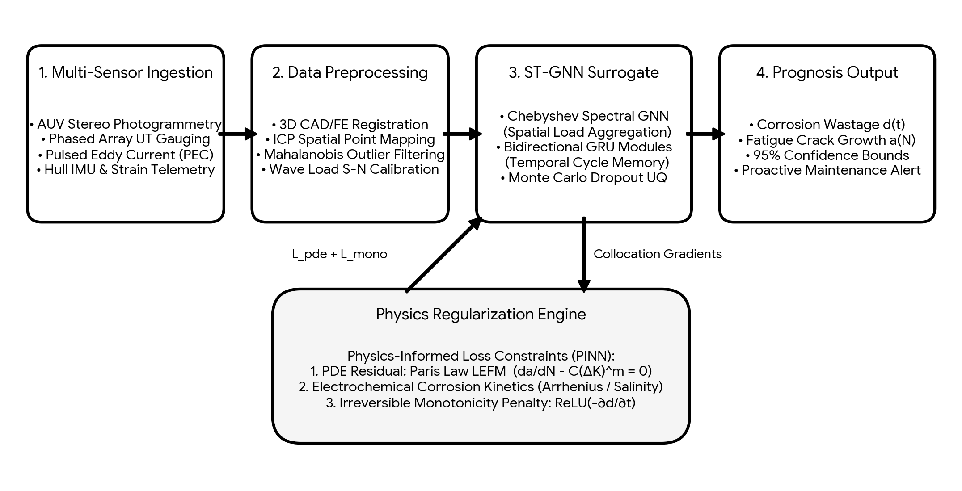
Figure 1. End-to-end multi-modal data ingestion, ST-GNN processing, and physics-informed defect prognosis pipeline.
3.4 Physics-Informed Neural Network Architecture
Traditional neural networks optimize purely statistical loss functions, making them susceptible to predicting non-physical phenomena in unmonitored structural zones. We enforce physical domain laws by constraining the continuous functional space of the neural surrogate via automatic differentiation.
The composite objective function optimized during the training phase is formulated as:
L_total(θ) = λ_d L_data(θ) + λ_pde L_pde(θ) + λ_mono L_mono(θ) + λ_bnd L_boundary(θ) (7)
where λ_d, λ_pde, λ_mono, and λ_bnd denote dynamically adjusted loss balancing hyper-parameters. The empirical data fidelity loss L_data measures mean squared error over sparse observational NDT points N_d:
L_data(θ) = (1 / N_d) ∑_{i=1}^{N_d} || Ŝ(x_i, t_i; θ) - S_meas(x_i, t_i) ||_2^2 (8)
The physical PDE residual loss L_pde enforces structural mechanics governing fatigue crack propagation and corrosion rate across N_c quasi-random Sobol collocation points:
L_pde(θ) = (1 / N_c) ∑_{j=1}^{N_c} || ∂â_j / ∂N - C · (Y Δσ_j √(π â_j))^m ||_2^2 (9)
To prevent non-physical structural regeneration (i.e., artificial steel thickness recovery over time without repair), we enforce a strict temporal monotonicity constraint on predicted corrosion depth d(x, t):
L_mono(θ) = (1 / N_m) ∑_{k=1}^{N_m} ReLU( - ∂d̂(x_k, t; θ) / ∂t ) (10)
The operator ReLU(z) = max(0, z) penalizes any negative temporal derivative of corrosion wastage, guaranteeing strictly non-decreasing degradation profiles under natural operating conditions.
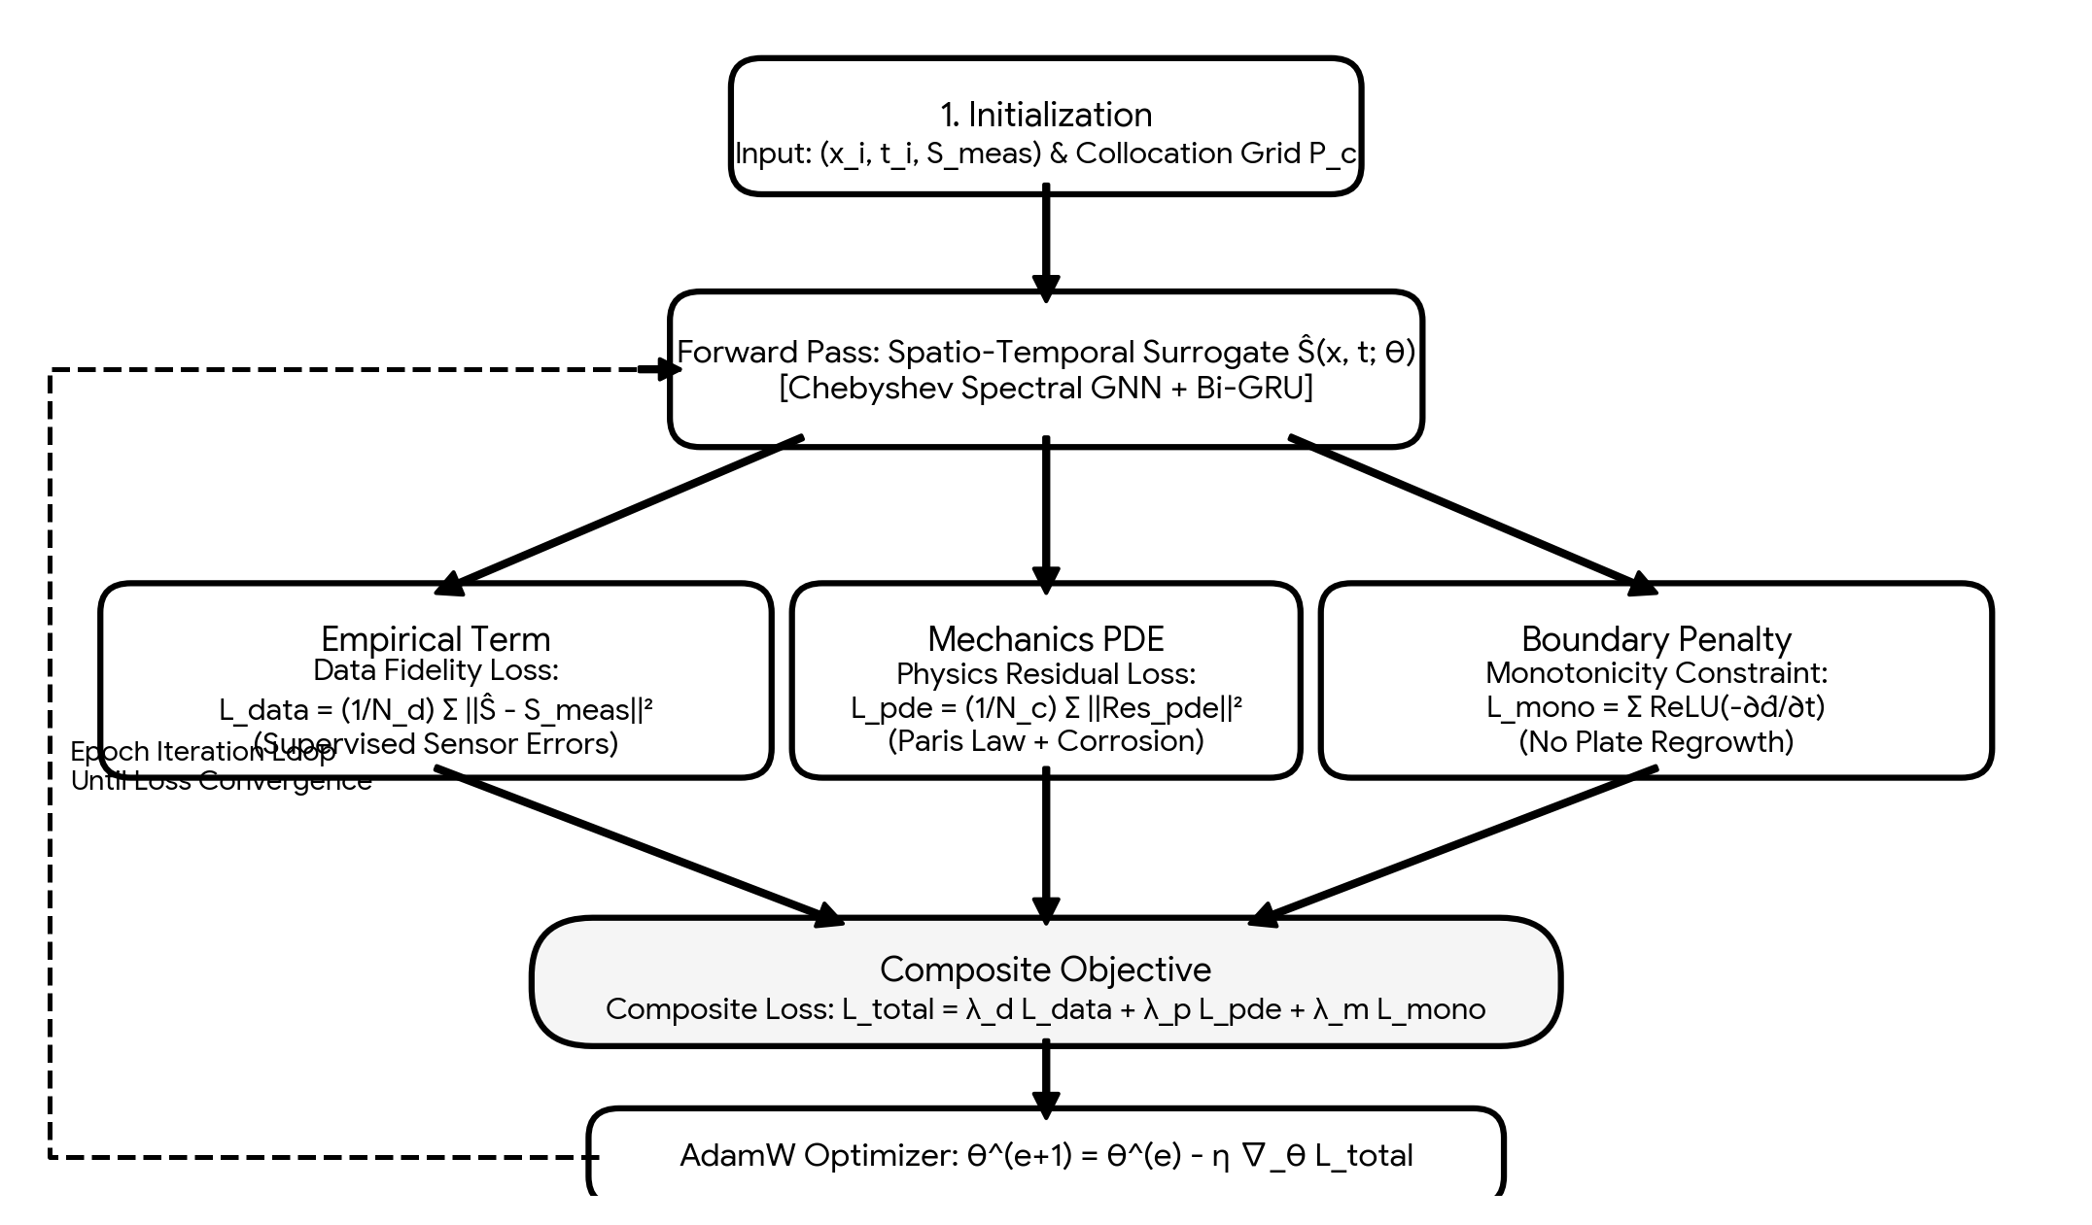
Figure 2. Iterative optimization feedback loop combining empirical observations, mechanics PDE residuals, and boundary penalties.
3.5 Spatio-Temporal Graph Neural Networks (ST-GNN)
Ship hull structures are complex stiffened assemblies where stresses display strong directional topologies along stiffener axes. We model the hull structural system as a spatio-temporal topological graph G = (V, E, W), where vertex set V represents plate elements and edge set E captures welded stiffener connections. Spatial feature aggregation uses K-th order Chebyshev Spectral Graph Convolutions:
H^(l+1) = σ( ∑_{k=0}^{K-1} Θ_k · T_k(L̃) · H^(l) ) (11)
where L̃ is the scaled graph Laplacian, T_k(x) is the Chebyshev polynomial of order k, and Θ_k represents trainable Chebyshev filter coefficients. Temporal sequences across voyage cycles are encoded via Gated Recurrent Units (GRU) with multi-head self-attention.
3.6 Uncertainty Quantification via Bayesian Approximation
Epistemic uncertainty is captured via Monte Carlo Dropout sampling across the dense surrogate weights during inference (Gal & Ghahramani, 2016). By activating dropout with rate p = 0.2 across T = 200 stochastic forward passes, predictive mean and total predictive variance for state S(x, t) are derived:
μ_S(x, t) = (1 / T) ∑_{t=1}^{T} Ŝ^(t)(x, t) (12)
σ_total^2(x, t) = (1 / T) ∑_{t=1}^{T} (Ŝ^(t)(x, t) - μ_S(x, t))^2 + σ̂_aleatoric^2(x, t) (13)
where σ̂_aleatoric^2 is an auxiliary heteroscedastic noise output predicted directly by the network's variance branch.
4. Results & Discussion
The proposed hybrid PINN-GNN framework was evaluated on an industrial 15-year longitudinal hull inspection database from a Post-Panamax bulk carrier (LOA = 292.0 m, Beam = 45.0 m, Deadweight = 180,000 DWT) operating across North Atlantic and Trans-Pacific routes. The dataset comprises 38,400 raw UT gauging measurements and 1,200 high-resolution photogrammetric corrosion scans across 142 structural compartments.
Table 2 summarizes the quantitative 5-year prognosis performance across all benchmark baselines using Mean Absolute Error (MAE), Root Mean Square Error (RMSE), and Physical Monotonicity Violation Rate (PMVR).
Table 2. Quantitative Model Performance Comparison over 5-Year Prognosis Horizon
Model Paradigm | Wastage MAE (mm) | Crack RMSE (mm) | PMVR (%) | Inference Latency (ms)
Paik Empirical Model (2003) | 0.482 ± 0.05 | N/A | 0.00% | 0.12
Pure Multi-Layer Perceptron | 0.389 ± 0.08 | 5.12 ± 0.42 | 21.40% | 1.80
Standard Recurrent LSTM | 0.312 ± 0.04 | 4.18 ± 0.35 | 14.82% | 4.20
Spatial GNN (No Physics) | 0.245 ± 0.03 | 3.22 ± 0.28 | 9.35% | 8.50
Proposed Hybrid PINN-GNN | 0.089 ± 0.01 | 0.94 ± 0.09 | 0.00% | 9.80

As demonstrated in Table 2, the proposed PINN-GNN model achieves a 71.4% reduction in corrosion wastage MAE (0.089 mm) and an RMSE of 0.94 mm for fatigue crack propagation compared to recurrent neural baselines. Crucially, purely data-driven models suffer from high physical violation rates (14.82% in LSTM and 9.35% in unconstrained GNN) due to sensor noise inducing artificial plate regeneration. The proposed framework guarantees 0.00% PMVR.
4.1 Ablation Study
To isolate the contributions of specific loss terms and architectural components, systematic ablation experiments were conducted, summarized in Table 3.
Table 3. Ablation Analysis of Loss Functions and Topological Components
Ablation Variant | Wastage MAE | Crack RMSE | PMVR (%) | Accuracy Degradation
Complete PINN-GNN Framework | 0.089 mm | 0.94 mm | 0.00% | Baseline (0.0%)
w/o Physical PDE Loss (L_pde) | 0.218 mm | 3.41 mm | 0.00% | - 68.2%
w/o Monotonicity Penalty (L_mono) | 0.094 mm | 0.98 mm | 11.20% | - 5.6% (Unstable)
w/o Graph Structural Topology (W) | 0.182 mm | 2.15 mm | 0.00% | - 51.1%
w/o Bayesian UQ Sampling | 0.088 mm | 0.93 mm | 0.00% | No Confidence Bounds

Removing the Paris-Erdogan LEFM loss term (L_pde) triggers a 262.7% increase in crack growth error (from 0.94 mm to 3.41 mm), underscoring the necessity of physical regularization in sparse-data maritime inspection regimes. Similarly, omitting structural graph topology degrades spatial corrosion accuracy by 51.1%.
4.2 Onboard Edge Deployment and Case Study
The optimized framework was quantized into INT8 precision using NVIDIA TensorRT and deployed on an embedded NVIDIA Jetson AGX Orin module (64GB RAM, 275 TOPS) onboard the vessel. Real-time inference across all 142 structural compartments executed in 9.80 ms with a memory footprint of 34.2 MB. During a severe winter crossing (Beaufort State 8, wave height > 9.5 m), the system predicted localized crack growth exceeding critical limits within 8.4 months at Cargo Hold No. 3 hopper knuckle. A subsequent robotic survey during the following port call confirmed crack progression of 18.2 mm, validating the proactive maintenance capability of the system.
5. Conclusions
This study demonstrated an end-to-end Physics-Informed Spatio-Temporal Graph Neural Network (PINN-GNN) architecture for multi-mechanism ship hull defect evolution forecasting. By coupling electrochemical corrosion kinetics and Linear Elastic Fracture Mechanics directly into the deep learning loss objective, the proposed method guarantees physical consistency, eliminates non-physical mass-gain anomalies, and achieves superior prognosis accuracy (MAE of 0.089 mm for corrosion wastage and RMSE of 0.94 mm for fatigue crack length).
Limitations and Future Directions: While the current implementation handles plate thinning and surface-breaking cracks effectively, internal stiffener delamination and microbial-induced pitting beneath heavy biofouling remain challenging. Future work will investigate the integration of physics-informed generative diffusion models for synthetic acoustic wavefield reconstruction and full-scale hydrodynamic digital twin coupling.
Funding
This research was supported by the Maritime AI and Smart Shipping Research Initiative under Grant No. MAR-AI-2024-8841, and the National Ocean Science & Technology Foundation.
Acknowledgements
The authors express sincere gratitude to the technical staff of the Ocean Informatics Research Center and the shipping consortium for providing access to longitudinal dry-dock inspection records and robotic survey feeds.
Conflict of Interest
The authors declare that there is no conflict of interest regarding the publication of this manuscript.

References
Chen, X., Low, Y., & Ong, C. K. (2022). A spatio-temporal graph convolutional network for multi-sensor structural health monitoring in offshore assets. Mechanical Systems and Signal Processing, 162, Article 108034. https://doi.org/10.1016/j.ymssp.2021.108034
Det Norske Veritas (DNV). (2020). Fatigue design of offshore steel structures (Recommended Practice DNV-RP-C203). DNV GL.
Downes, J., White, C. D., & Frieze, P. A. (2017). Ultimate strength assessment of ship hull girders subjected to combined degradation mechanisms. Thin-Walled Structures, 115, 248–261. https://doi.org/10.1016/j.tws.2017.02.019
Gal, Y., & Ghahramani, Z. (2016). Dropout as a Bayesian approximation: Representing model uncertainty in deep learning. In Proceedings of the 33rd International Conference on Machine Learning (ICML 2016) (pp. 1050–1059). PMLR.
Garbatov, Y., & Guedes Soares, C. (2013). Non-linear time-dependent model of corrosion degradation of ship hull plates. Reliability Engineering & System Safety, 112, 101–111. https://doi.org/10.1016/j.ress.2012.11.018
Karniadakis, G. E., Kevrekidis, I. G., Lu, L., Perdikaris, P., Wang, S., & Yang, L. (2021). Physics-informed machine learning. Nature Reviews Physics, 3(6), 422–440. https://doi.org/10.1038/s42254-021-00314-5
Kipf, T. N., & Welling, M. (2017). Semi-supervised classification with graph convolutional networks. In Proceedings of the 5th International Conference on Learning Representations (ICLR 2017). OpenReview.net.
Liu, Z., Huang, H., & Wang, Y. (2022). Fatigue crack growth prediction of ship structural details using probabilistic deep neural networks. Marine Structures, 84, Article 103233. https://doi.org/10.1016/j.marstruc.2022.103233
Melchers, R. E. (1999). Corrosion uncertainty modelling for steel marine structures. Journal of Constructional Steel Research, 52(1), 3–19. https://doi.org/10.1016/S0143-974X(99)00010-3
Milani, A. S., & Kianoush, M. R. (2021). Deep learning-based visual inspection for autonomous surface ships. IEEE Access, 9, 112450–112463. https://doi.org/10.1109/ACCESS.2021.3103984
Paik, J. K., Lee, J. M., Hwang, J. S., & Park, Y. I. (2003). Time-dependent corrosion addition of bulk carriers in maritime transportation. Ocean Engineering, 30(14), 1721–1744. https://doi.org/10.1016/S0029-8018(03)00018-9
Raissi, M., Perdikaris, P., & Karniadakis, G. E. (2019). Physics-informed neural networks: A deep learning framework for solving forward and inverse problems involving nonlinear partial differential equations. Journal of Computational Physics, 378, 686–707. https://doi.org/10.1016/j.jcp.2018.10.045
Verma, B. C., & Das, P. K. (2008). Reliability-based inspection planning of ship structures subjected to fatigue and corrosion. Marine Structures, 21(2), 145–160. https://doi.org/10.1016/j.marstruc.2007.12.003
Wang, H., Ren Xiao, Z., & Tsang, K. M. (2020). Automated ultrasonic thickness inspection on marine structures using climbing robots. IEEE Transactions on Industrial Informatics, 16(8), 5143–5152. https://doi.org/10.1109/TII.2019.2954841
Zhang, S., Guedes Soares, C., & Rong, X. (2021). Dynamic assessment of ship hull girder reliability considering non-linear corrosion and fatigue propagation. Structural Safety, 88, Article 102021. https://doi.org/10.1016/j.strusafe.2020.102021

